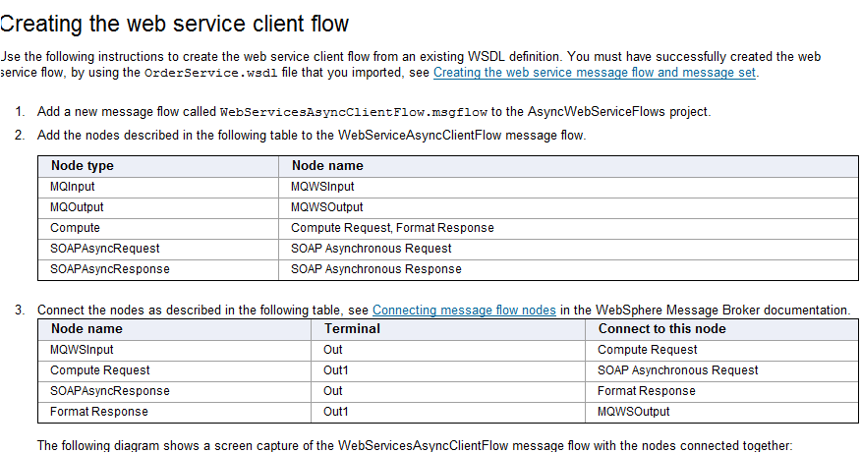

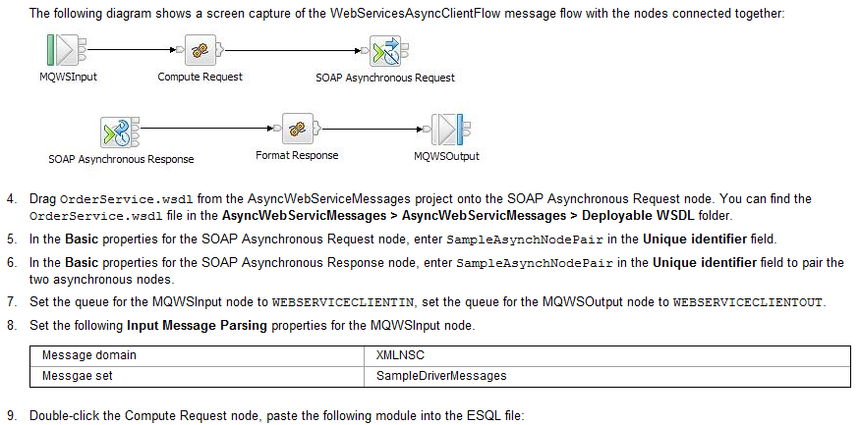

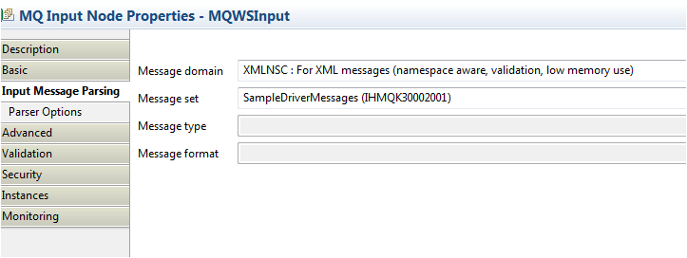

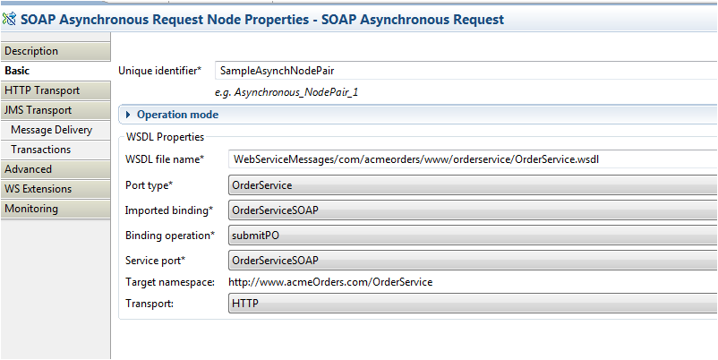

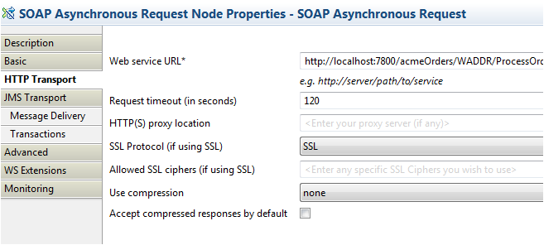
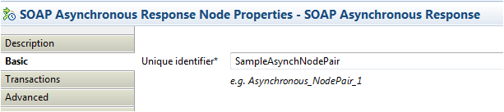

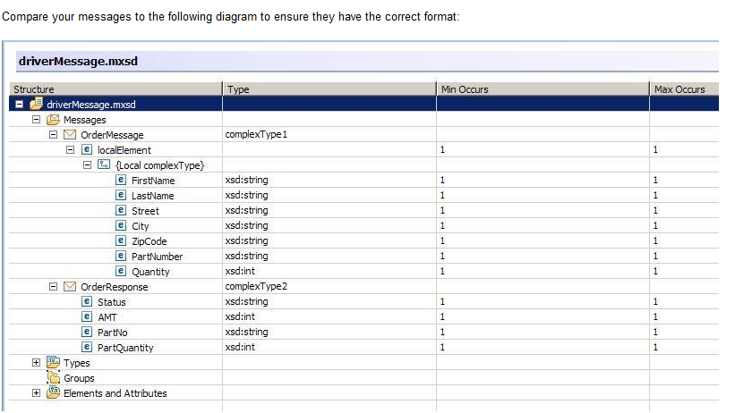

Creating the web service message flow and message set
Use the following instructions to create the web service flow message flow and message set from a WSDL definition.
- Save the OrderService.WSDL file to your workspace, for example, C:\Documents and Settings\<username>\IBM\wmbt70\workspace\OrderService.wsdl.
- In the Broker Development view, click Start from WSDL and/or XSD files. The Quick Start wizard is displayed.
- In the Message flow project name field, type AsyncWebServiceFlows.
- In the Message set project name field, type AsyncWebServiceMessages.
- In the Message set name field, type AsyncWebServiceMessages.
- In the Message flow name field, type AsyncWebSebServiceServerFlow.
- Clear Create a new working set for these resources. The completed values for the Quick Start wizard are shown in the following diagram:

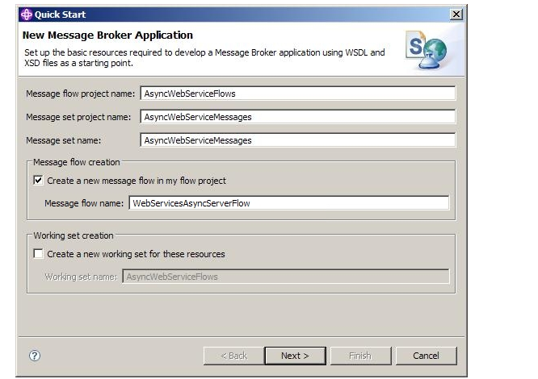

- Click Next.
- Select Use external resources, click Browse.
- Locate the OrderService.wsdl file from your workspace, click OK.
- Click Next.
- Click Finish. A blank message flow and a message set based on the WSDL file are created.
- Add the following nodes to the WebServiceAsyncServerFlow message flow.

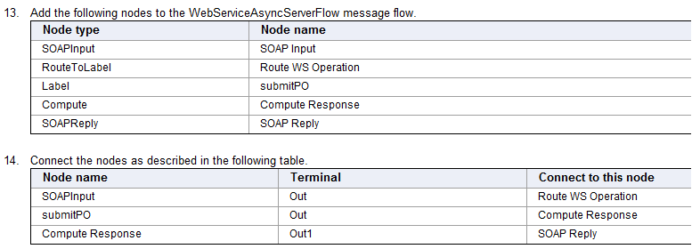

- For more information about connecting nodes, see Connecting message flow nodes in the WebSphere Message Broker documentation.
The following diagram shows the WebServiceAsyncServerFlow message flow with the nodes connected together:
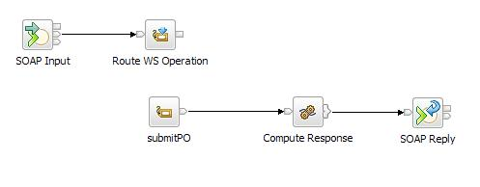
- Drag OrderService.wsdl from the AsyncWebServiceMessages project, onto the SOAP Input node. You can find the OrderService.wsdl file in AsyncWebServicMessages > AsyncWebServicMessages > Deployable WSDL.
- Select Use WS-Addressing on the WS Extensions tab of the SOAP Input node properties. WS-Addressing headers are used in all the SOAP messages for this web service.
- Double-click the Compute Response node, paste the following module into the ESQL file:

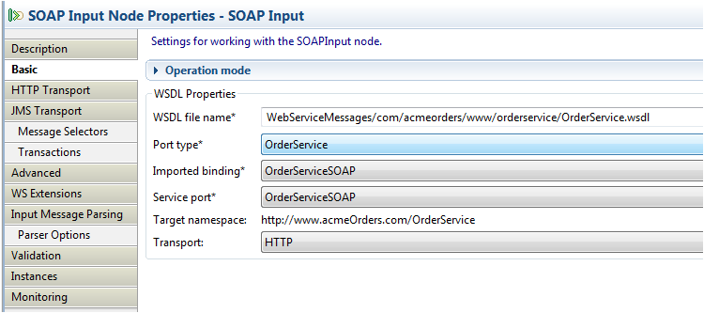

/*Sample program for use with IBM WebSphere Message Broker
© Copyright International Business Machines Corporation 2007, 2010
Licensed Materials - Property of IBM*/

DECLARE ns NAMESPACE 'http://www.acmeOrders.com/OrderService';

CREATE COMPUTE MODULE WebServicesAsyncClientFlow_Compute
CREATE FUNCTION Main() RETURNS BOOLEAN
BEGIN
DECLARE inMsg REFERENCE TO InputRoot.XMLNSC.OrderMessage.localElement;
SET OutputRoot.SOAP.Body.ns:submitPORequest.partNo = inMsg.PartNumber;
DECLARE outMsg REFERENCE TO OutputRoot.SOAP.Body.ns:submitPORequest;
SET outMsg.partQuantity = inMsg.Quantity;
SET outMsg.personName.firstName = inMsg.FirstName;
SET outMsg.personName.lastName = inMsg.LastName;
SET outMsg.address.street = inMsg.Street;
SET outMsg.address.city = inMsg.City;
SET outMsg.address.zipCode = inMsg.ZipCode;

RETURN TRUE;
END;
END MODULE;

CREATE COMPUTE MODULE WebServicesAsyncClientFlow_Format
CREATE FUNCTION Main() RETURNS BOOLEAN
BEGIN
SET OutputRoot.Properties.MessageSet = 'SampleDriverMessages';
SET OutputRoot.Properties.MessageType = 'OrderResponse';

DECLARE inMsg REFERENCE TO InputRoot.SOAP.Body.ns:submitPOResponse;
SET OutputRoot.XMLNSC.OrderResponse.PartNo = inMsg.partNo;
DECLARE respMsg REFERENCE TO OutputRoot.XMLNSC.OrderResponse;
SET respMsg.PartQuantity = inMsg.partQuantity;
SET respMsg.AMT = inMsg.orderAmt;
SET respMsg.Status = inMsg.orderStatus;

RETURN TRUE;
END;
END MODULE;

/*Sample program for use with IBM WebSphere Message Broker
© Copyright International Business Machines Corporation 2007, 2010
Licensed Materials - Property of IBM*/

CREATE COMPUTE MODULE WebServicesAsyncServerFlow_Compute
CREATE FUNCTION Main() RETURNS BOOLEAN
BEGIN
SET OutputRoot.SOAP.Body.ns:submitPOResponse.orderStatus = 'AVAILABLE';
DECLARE outMsg REFERENCE TO OutputRoot.SOAP.Body.ns:submitPOResponse;
DECLARE inMsg REFERENCE TO InputRoot.SOAP.Body.ns:submitPORequest;
SET outMsg.orderAmt = 50;
SET outMsg.partNo = inMsg.partNo;
SET outMsg.partQuantity = inMsg.partQuantity;

RETURN TRUE;
END;
END MODULE;

